
Gas Regulator School 2026
November 12th-13th,2026

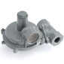
- Date: November 12th-13th, 2026
- Duration: 2 Days
- Time: 9:00 a.m. - 4:30 p.m. Thursday
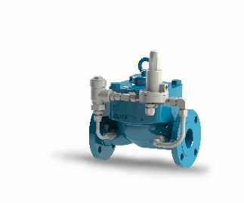
8:30 a.m. – 2:00 p.m. Friday
- Instructors: Gregg Schneider- (Baker Hughes) & John Viner
(AY McDonald)
- Fee: $450.00
- Location: Devtech’s Jim Estilette Training Center
118 South Lake Avenue
Avon Park, FL 33825

- Topics covered include function, construction, operation, capacities, and sizing of gas regulators as well as pertinent DOT and PSC regulations (suggested that students attend our Gas Measurement course prior to this course).
- Training materials provided.
- Your company will be invoiced using a purchase order or a billing contact at your company.
- Please return the completed registration form (attached) to Devtech via email, fax, or mail by October 30, 2026. Cancellations made after that date will be subject to a 50% fee. Please note this class is limited to the first 25 registrants.
- You will receive a confirmation email once you are enrolled. If you do not receive confirmation,
we do not have you enrolled for the school. Please contact 863-453-5959 with any questions.

Check out our “Training” page for future schools & seminars on our website
www.devtechsales.com/training.html

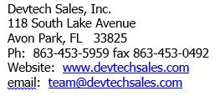

Devtech Sales, Inc.
Gas Regulator School 2026
November 12-13, 2026

Student’s
Name:
Company or Utility:
Position:
Phone:
Email Address:
Mailing Address: (for test scores & certificate)
Billing Address: (if different from mailing)
PO Number or
Credit Card #:
*Name on card
*Exp. Date
*Address associated with card.
*CVC # on back
Supervisor’s Name:

For further information please visit our website;
www.devtechsales.com/training.html.

