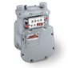
“Gas Measurement School 2022”

- Date: February 22nd-23rd 2022
- Duration: 2 Days
- Time: 9:00 a.m. - 4:30 p.m. Tuesday
8:30 a.m. - 3:30 p.m. Wednesday
- Facilitator: Bob Bennett /Honeywell American Meter
- Fee: $400.00/per person
- Location: Devtech’s Jim Estilette Training Center
118 South Lake Avenue
Avon Park, FL 33825
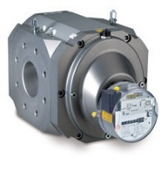
- Topics covered include function and handling of gas meters, sizing, pressure limits and capacities, pressure and temperature calculations, explanation of errors caused by measurement loss
- Training materials provided (please bring a calculator)
- Your company will be invoiced, following the class, either via your purchase order number or billing contact at your company
- Please return the attached completed registration form to Devtech via email, fax, or mail by February 15, 2022. Cancellations made after this date will be subject to a 50% fee. Please note this class is limited to the first 25 registrants.
- You will receive a confirmation email once you are enrolled. If you do not receive a confirmation, we do not have you enrolled for the school. Please contact 863-453-5959 with any questions.

Check out our “Training” page for future schools & seminars on our website
www.devtechsales.com/training.html

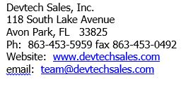
Devtech Sales, Inc.
“Gas Measurement School”
February 22nd-23rd 2022
Student’s Name:
Company or Utility:
Position:
Phone:
Fax:
Email Address:
Mailing Address: (for test scores & certificate)
Billing Address: (if different from mailing)
PO Number or
Credit Card #:
*Name on card
*Exp. Date
*Address associated with card.
Supervisor’s Name:

For further information, please visit our website; www.devtechsales.com/training.html.

